News tone

Pitch draft

Ying wang: a1733805

Yiru Li: a1736798

Jin Zhou：a1758331

1. What do we do?

Our project is an application of sentiment analysis named ‘News tone’. We are going to develop a program that can grab the index web page of a news site on a day to analyze the sentiment of it. By analyzing the historical data of the site for a given period, it will display the sentiment outcomes on a dashboard for the convenience of users’ utilization. The purpose of our project is to provide a sentiment analysis algorithm for news to distinguish whether a news report is positive or negative.

1. Why do we do this?

People can easily identify each other's emotions such as happiness, sadness, horror and anger during an interaction base on body languages, mood, and expression. However, it is difficult for us to analyze the emotional tendencies of all people in society due to a large number of samples. Understanding the overall sentiment of society is a vital technique which has a variety of advantages in many aspects. For instance, it could assist the financial sector to adopt appropriate strategies to deal with market panics that may occur in the future in advance. This may help relevant stakeholders to avoid a huge loss of wealth. Moreover, analyzing and mining news material information through sentiment analysis to obtain public opinion's sentiment on some hot issues so that it can provide a scientific basis for the strategic decision direction of the government and enterprises.

As a sentiment analysis program, it is necessary to analyze the emotional tendencies of news reports and news reviews at the same time, in order to correctly analyze the public's attitudes to a hot issue such as a certain policy and corporate dynamic.

1. Example of sentiment analysis application

Stocksight - a prediction/analysis platform of the stock market based on sentiment analysis of twitter and titles of news.

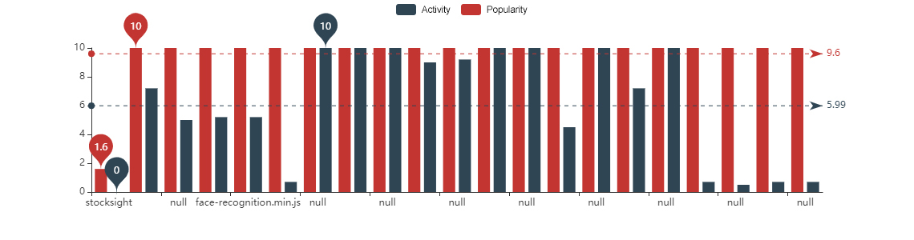

Stock sight is a crowd-sourced stock analysis open-source software that uses Elasticsearch to store Twitter and news headlines data for stocks. Stock sight analyzes the emotions of what the author writes and does sentiment analysis on the text to determine how the author "feels" about a stock. Stock sight makes an aggregated analysis of all collected data from all sources.

Each user running stock sight has a unique fingerprint: specific stocks they are following, news sites and twitter users they follow to find information for those stocks. This creates a unique sentiment analysis for each user, based on what data sources they are getting stocksight to search. Users can have the same stocks, but their data sources could vary significantly creating different sentiment analysis for the same stock. stocksight website will allow each user to see other sentiment analysis results from other stock sight user app results and a combined aggregated view of all.

1. How would the problem be solved?

Through sentiment analysis, we divide news headlines on news sites into positive and negative types based on machine learning. Due to time constraint, our program is divided into 6 steps:

Step 1：Extract news content for training.

Step 2：Feature extraction for training news.

Step 3：Training based on news features and machine learning algorithms and establishing a News sentiment analysis model.

Step 4：Extract news content to be identified.

Step 5：Extracting features of news to be identified.

Step 6：Determine whether the news is a positive or negative report based on the features of the news to be identified and the news sentiment model.

1. Project allocation

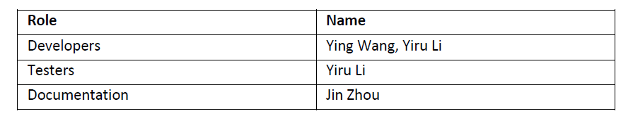

In our team, each member has his/her responsibility for this project. Based on the table above, Ying and Yiru are responsible for developing and testing the program and Jin is responsible for the documentation. The risks or issues, which may occur during the process will be recorded in the document as challenges and at the end of the project, we can learn from these experiences and improve efficiency for further developing. Necessary modifications may apply to adjust or improve the final performance of the program, in words, programming algorithm procedures may vary from the plan which described in section four.